

MSc Data Science Project
Department of Physics, Astronomy and Mathematics

Data Science FINAL PROJECT REPORT

Project Title:
Data-Driven Modeling of Urban Air Quality (AQI) Using Integrated Machine Learning and Feature Importance Techniques

Student Name and SRN:
Guru Jagadeesh Baleboina and 23085303

Supervisor: Souradeep Bhattacharya
Date Submitted: 06/01/2026
Word Count: 4988
Github Link: https://github.com/gurubaleboina/Data-Driven-Modeling-of-Urban-Air-Quality-AQI-Using-Integrated-Machine-Learning-/blob/main/README.md

MSc Final Project Declaration

This report is submitted in partial fulfilment of the requirement for the degree of Master of Science in Data Science at the University of Hertfordshire.
I have read the detailed guidance to students on academic integrity, misconduct and plagiarism information at Assessment Offences and Academic Misconduct and understand the University process of dealing with suspected cases of academic misconduct and the possible penalties, which could include failing the project or course.
I certify that the work submitted is my own and that any material derived or quoted from published or unpublished work of other persons has been duly acknowledged. (Ref. UPR AS/C/6.1, section 7 and UPR AS/C/5, section 3.6)
I did not use human participants in my MSc Project.

I hereby give permission for the report to be made available on module websites provided the source is acknowledged.

Student Name printed: Guru Jagadeesh Baleboina
Student Name signature: gurujagadeesh
Student SRN number: 23085303

UNIVERSITY OF HERTFORDSHIRE
SCHOOL OF PHYSICS, ENGINEERING AND COMPUTER SCIENCE

Acknowledgements
I sincerely thank my project supervisor for invaluable guidance, feedback, and support throughout this research. I am grateful to the University of Hertfordshire’s School of Physics, Engineering and Computer Science for providing essential resources and academic environment. I acknowledge the Open-Meteo Air Quality API for publicly accessible datasets that enabled this work. Finally, heartfelt thanks to my family and friends for their constant encouragement and support.

Table of Contents
Abstract 6
1. Introduction 7
1.1 Aim and Research Questions 8
1.2 Objectives 8
1.3 Report Structure 9
2. Literature Review 10
2.1 Introduction 10
2.2 Evolution of Machine Learning Algorithms for Air Quality Forecasting 10
2.3 Temporal Feature Engineering and Sequential Pattern Recognition 11
2.4 Temporal Validation Methodologies in Air Quality Forecasting 12
2.5 Performance Evaluation Metrics for Forecasting Models 12
2.6 Research Gaps and Motivation for Current Study 13
3. Dataset and Ethical Issues 14
3.1 Dataset 14
3.2 Ethical Issues 15
4. Methodology 17
4.1 Research Design and Temporal Splitting Strategy 17
4.2 Feature Engineering 18
4.3 LSTM Network 18
4.4 XGBoost 19
4.5 SVM Regression 19
4.6 Evaluation Metrics 20
4.7 Future Forecasting (2026-2030) 20
5. Results and Discussion 22
5.1 LSTM Model Performance 22
5.2 XGBoost Model Performance 23
5.3 SVM Model Performance 24
5.4 Comparative Model Analysis 25
5.5 Temporal Prediction Patterns 25
5.6 Comparison to Literature 27
5.7 Future Forecasts Analysis (2026-2030) 27
5.8 Answering Research Questions and Meeting Objectives 28
6. Conclusion 29
References 31
Appendices 37
Appendix A: Air Quality using PM2.5 Implementation 37
Appendix B: Open-Meteo Citation 66

Abstract
Air pollution causes approximately 7 million premature deaths annually, with PM₂.₅ identified as the most critical pollutant due to severe health impacts. Traditional air quality assessment relies on static monitoring and retrospective analysis, limiting proactive public health management. This research develops a machine learning framework for forecasting urban PM₂.₅ concentrations in London using 12.5 years of daily measurements (April 2013-September 2025) from Open-Meteo Air Quality API. The study compares three machine learning paradigms under rigorous temporal validation: Long Short-Term Memory (LSTM) networks for sequential learning, Extreme Gradient Boosting (XGBoost) for feature-based prediction, and Support Vector Machines (SVM) for nonlinear regression. Models were trained on 2013-2021 data (3,197 samples) and tested on 2022-2025 data (1,369 samples) to prevent data leakage. LSTM substantially outperformed traditional methods, achieving RMSE of 4.03 μg/m³ and R² of 0.50 compared to XGBoost (RMSE 5.58 μg/m³, R² 0.062) and SVM (RMSE 5.93 μg/m³, R² -0.058). This 28% lower error rate demonstrates that sequential learning capturing autoregressive patterns significantly outperforms feature-based methods. Five-year forecasts (2026-2030) demonstrated operational capability but revealed long-term limitations. The framework provides evidence-based guidance for practitioners and offers a deployable solution for operational air quality monitoring and public health protection.
Keywords: Urban Air Quality, PM₂.₅ Forecasting, Time Series Analysis, Long Short-Term Memory (LSTM), XGBoost, Support Vector Regression, Temporal Validation; Machine Learning, Feature Importance, Environmental Data Science.

1. Introduction
Air pollution is among the most pressing environmental and public health challenges of the 21st century, with significant implications for climate stability, ecosystem balance, and human well-being. According to the World Health Organization (2025), air pollution causes approximately 7 million premature deaths annually, making it one of the leading global environmental risk factors. In the United Kingdom, air pollution contributes to an estimated 28,000-36,000 premature deaths each year (Department of Health and Social Care, 2024), primarily due to exposure to particulate matter (PM₂.₅ and PM₁₀), nitrogen dioxide (NO₂), ozone (O₃), carbon monoxide (CO), and sulphur dioxide (SO₂).
Urban environments face elevated pollution from dense populations and traffic (Kumar and Maharana, 2020). Many cities exceed WHO guidelines despite regulations, with London representing a critical case study for urban air quality dynamics.
Current air quality management relies on static monitoring and retrospective statistical analysis, effective for measuring present conditions but limited in forecasting future levels (Izah et al., 2024). Such approaches struggle to capture complex, nonlinear, temporally dependent relationships between pollutants, meteorological influences, and seasonal variability. As a result, existing systems provide limited support for proactive public health interventions, such as early warning systems and preventive policy measures (Rosca et al., 2025).
Particulate Matter 2.5 (PM₂.₅) is the primary focus of this study due to its severe health implications. PM₂.₅ particles can penetrate deep into the respiratory system and bloodstream, contributing to cardiovascular disease, respiratory illness, and premature mortality (Gamal et al., 2025). While machine learning has increasingly been applied to air quality forecasting, many existing studies suffer from methodological weaknesses, particularly the use of random train–test splits that introduce temporal data leakage and produce overly optimistic performance estimates.
This project develops a machine learning framework for forecasting urban PM₂.₅ concentrations using rigorous time series analysis. The framework compares three approaches: Long Short-Term Memory (LSTM) networks for sequential learning, Extreme Gradient Boosting (XGBoost) for feature-based regression, and Support Vector Machines (SVM) for nonlinear prediction. Models are trained on 2013–2021 data and tested on 2022–2025 data to ensure realistic performance evaluation, with forward forecasts generated for 2026–2030.
Accurate forecasting enables timely health advisories for public health authorities and policymakers (Rajesh et al., 2025). Environmental consultancies may integrate such models into monitoring systems (Lloret et al., 2025). Using publicly available Open-Meteo data, the framework is transparent and deployable while acknowledging ethical considerations in prediction communication.

1.1 Aim and Research Questions
1.1.1 Aim of the Project
This research aims to develop an interpretable, data-driven machine learning framework that accurately forecasts urban air quality concentrations using temporal analysis and comparative evaluation of deep learning and traditional machine learning approaches.
1.1.2 Research Questions
- Can machine learning models accurately forecast future air quality concentrations using historical temporal data, and which approach (sequential learning vs feature-based methods) provides superior predictive performance?
- How do temporal patterns and trends in air quality evolve over time, and can these patterns be reliably extrapolated for long-term forecasting?

1.2 Objectives
- To collect and preprocess daily London air quality data (2013-2025) from the Open-Meteo API, implementing rigorous temporal splitting (training: 2013-2021, testing: 2022-2025) to prevent data leakage and ensure realistic performance evaluation.
- To develop, optimize, and compare three machine learning approaches for time series forecasting LSTM, XGBoost, and SVM through systematic hyperparameter tuning using RandomizedSearchCV, GridSearchCV, and early stopping techniques.
- To evaluate model performance comprehensively using multiple regression metrics (RMSE, MAE, MAPE, R²) and generate future forecasts (2026-2030) demonstrating operational capability for long-term prediction.
- To visualize temporal trends, model predictions, and performance comparisons to provide actionable insights for air quality monitoring and policy support.

1.3 Report Structure
This report is structured as follows: Chapter 2 reviews relevant literature on air quality forecasting. Chapter 3 presents the dataset and ethical considerations. Chapter 4 details the methodology. Chapter 5 presents results and comparative performance discussion. Chapter 6 concludes with evaluation, key insights, and future work recommendations.

2. Literature Review

2.1 Introduction
Air pollution remains one of the most significant environmental and public health challenges worldwide (Vilcins et al., 2024). Urban air quality is influenced by multiple pollutants, including particulate matter (PM₂.₅ and PM₁₀), nitrogen dioxide (NO₂), sulfur dioxide (SO₂), ozone (O₃), and carbon monoxide (CO), whose interactions are complex, nonlinear, and temporally dependent (Thanekar, 2025). Among these, PM₂.₅ has emerged as a critical indicator due to its ability to penetrate deep into the respiratory system, making accurate forecasting essential for mitigating adverse health impacts.
Machine learning has transformed air quality forecasting by capturing nonlinear relationships and temporal dependencies more effectively than traditional approaches (Essamlali et al., 2024). This review synthesises peer-reviewed research on machine learning-based PM₂.₅ forecasting, focusing on regression and sequential learning with validated temporal methodologies. The review examines algorithm evolution, temporal representation, validation techniques, and evaluation metrics, identifying key research gaps motivating this study.

2.2 Evolution of Machine Learning Algorithms for Air Quality Forecasting
Early work in air quality forecasting primarily employed regression-based models. Madan et al. (2020) compared Linear Regression, Decision Trees, Random Forests, Artificial Neural Networks (ANN), and Support Vector Machines (SVM), demonstrating that neural networks were more effective at modelling nonlinear temporal patterns, while ensemble tree-based methods offered robustness on large datasets.
Subsequent studies highlighted the growing dominance of boosting-based ensembles. Kothandaraman et al. (2022) evaluated multiple regression algorithms for PM₂.₅ forecasting using historical data and reported that XGBoost achieved superior performance (RMSE = 13.85 μg/m³, MAE = 8.27 μg/m³) compared to simpler models, attributing improvements to effective exploitation of engineered temporal features. Sanjeev (2021) similarly found that Random Forest and SVM models performed competitively when combined with lagged pollutant variables and calendar-based features.
More recent research explored hybrid and large-scale implementations. Varghese et al. (2023) proposed a hybrid Polynomial Regression–XGBoost model, achieving R² = 0.85 under temporal validation and demonstrating the importance of rigorous preprocessing. Vishwakarma et al. (2025) assessed regression models using large datasets and strict temporal validation, reporting strong performance for tree-based methods (Random Forest RMSE = 1.16, R² = 0.99). However, these studies largely focused on feature-based approaches, offering limited direct comparison with sequential deep learning models such as Long Short-Term Memory (LSTM) networks under identical evaluation conditions.

2.3 Temporal Feature Engineering and Sequential Pattern Recognition
A key methodological distinction in air quality forecasting lies in how temporal dependencies are captured. Feature-based models such as XGBoost and SVM rely on explicit temporal variables, while sequential models such as LSTM learn temporal patterns directly from ordered observations.
Gupta et al. (2023) analysed temporal feature importance using Support Vector Regression, Random Forest, and CatBoost, showing that features such as month, season, and day of year contributed up to 30% of predictive importance. Incorporating lagged PM₂.₅ values (1-7 days) reduced RMSE by approximately 15-20%, highlighting the value of temporal memory in forecasting tasks.
Thamizhselvi et al. (2023) demonstrated that temporal feature relevance varies with forecasting horizon: recent lagged values dominated next-day predictions, while seasonal features became more influential for longer horizons. Patil et al. (2020) further showed that temporal feature importance is geographically dependent, reflecting differences in emission sources and meteorological conditions.
These findings underscore a fundamental trade-off. Feature-based approaches offer interpretability through feature importance analysis but require extensive domain expertise. In contrast, sequential learning models such as LSTM automatically capture autoregressive dependencies but provide limited transparency. Determining which paradigm offers superior predictive performance under rigorous temporal validation remains an open question addressed by this study.

2.4 Temporal Validation Methodologies in Air Quality Forecasting
Validation strategy is critical in time-series forecasting. Random train-test splitting can introduce temporal data leakage, leading to inflated performance estimates. Kothandaraman et al. (2022) demonstrated that XGBoost achieved substantially lower error under random cross-validation compared to temporal validation, indicating overly optimistic evaluation when temporal order is ignored.
Varghese et al. (2023) employed sequential validation, ensuring models were trained exclusively on historical data and evaluated on future observations. Under this strategy, R² values decreased by approximately 0.10-0.15 compared to random splitting, but provided more realistic estimates of forecasting capability. Vishwakarma et al. (2025) extended this approach using rolling-window validation, enabling assessment of model stability across multiple temporal regimes.
Thamizhselvi et al. (2023) emphasised that air quality data are inherently autocorrelated, meaning that random validation exploits temporal proximity rather than genuine predictive learning. These findings establish temporal validation as a methodological necessity and directly inform the evaluation strategy adopted in the present research.

2.5 Performance Evaluation Metrics for Forecasting Models
Regression-based air quality forecasting studies commonly employ RMSE, MAE, MAPE, and R² to evaluate performance (Kothandaraman et al., 2022). RMSE is particularly relevant in environmental contexts because it penalises large errors, which often correspond to high-pollution events with severe public health consequences.
Gupta et al. (2023) and Sanjeev (2021) caution that high R² values may be misleading in time-series forecasting if models primarily capture persistence rather than meaningful temporal dynamics. Vishwakarma et al. (2025) conducted residual analysis and showed that many models perform well under moderate pollution levels but exhibit increased errors during extreme events. Ensemble methods demonstrated more balanced error distributions, suggesting improved robustness.
The gap between training and testing performance also provides insight into model generalisation. Kothandaraman et al. (2022) observed larger performance degradation for complex models compared to simpler ones, motivating the use of regularisation, early stopping, and careful hyperparameter optimisation.

2.6 Research Gaps and Motivation for Current Study
Despite extensive research, several gaps remain. First, few studies provide systematic comparison between sequential learning models and feature-based approaches under identical temporal validation conditions. Existing comparisons largely exclude LSTM models, limiting understanding of their relative effectiveness.
Second, while temporal feature importance is well established, limited work directly contrasts explicit feature engineering with implicit sequence learning. This distinction has practical implications for model interpretability, scalability, and deployment.
Third, most reviewed studies focus on datasets from India or China, with limited evaluation of London air quality data using multi-year temporal validation. Fourth, comparative analysis of hyperparameter optimisation strategies across different model classes remains sparse. Finally, long-term forecasting beyond immediate test periods has received limited attention.
These gaps motivate the present study, which systematically compares LSTM, XGBoost, and SVM models for PM₂.₅ forecasting using rigorous temporal validation, comprehensive performance metrics, and extended future prediction for the period 2026-2030.

3. Dataset and Ethical Issues

3.1 Dataset
Air quality data was obtained from the Open-Meteo Air Quality API (Open-Meteo, 2025) at https://open-meteo.com/en/docs/air-quality-api, providing daily measurements for London from April 2013 to September 2025 (4,566 observations over 12.5 years). The data originates from CAMS European air quality forecasts through the Copernicus Atmosphere Monitoring Service (CAMS, 2022), which aggregates measurements from European governmental environmental monitoring networks using automated monitoring stations with hourly measurements aggregated into daily means. The dataset contains seven pollutants: PM₁₀, PM₂.₅, CO, NO₂, SO₂, O₃, and dust (μg/m³), collected for regulatory compliance and public health surveillance.
This dataset was chosen for four justified reasons: (1) Temporal coverage 12.5 years provides sufficient data for LSTM training while enabling multi-year testing (2022-2025) for rigorous temporal validation; (2) Target variable relevance PM₂.₅’s severe health impacts make accurate forecasting essential (Patel et al., 2025; Khamnuan et al., 2025); (3) Reproducibility- publicly available API-based access using Python’s requests library (Ahmadi, 2025); (4) Policy context-London’s Ultra Low Emission Zone provides real-world regulatory context.
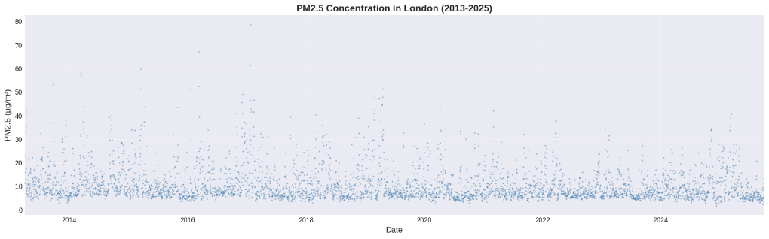
Figure 1: Daily PM2.5 Concentrations in London (2013-2025)
Exploratory analysis revealed PM₂.₅ ranged 1.71-78.73 μg/m³ (mean: 10.77, SD: 7.21, median: 8.30), with positive skewness indicating high-pollution episodes (Huang, 2025). Yearly analysis showed declining concentrations from ~12.5 μg/m³ (2013) to ~8.5 μg/m³ (2025), reflecting regulatory interventions (Khalil, 2015). Seasonal patterns revealed winter (13-15 μg/m³) higher than summer (7-9 μg/m³) due to reduced atmospheric mixing and heating emissions.
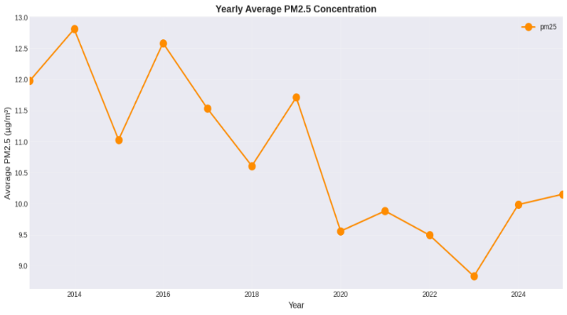
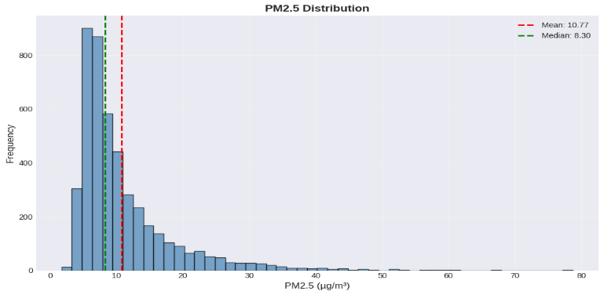
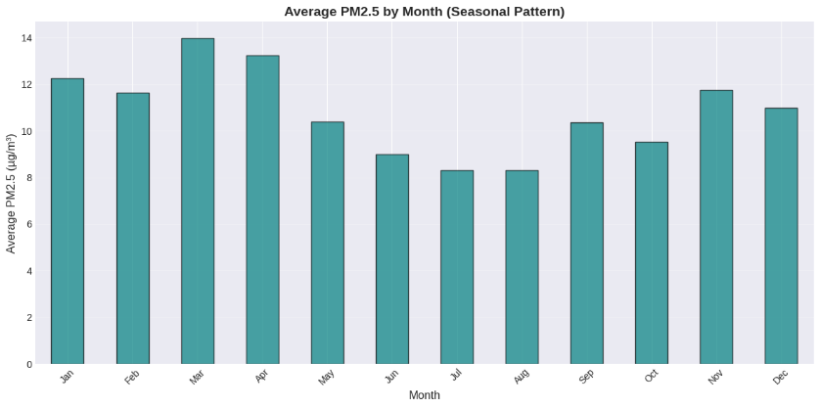
Figure 2: Distribution, Yearly Trends, Monthly Seasonality
Data preprocessing involved converting dates to datetime format, indexing, and sorting chronologically (Guyet and Duvermy, 2025). Missing values: CO (1,005, 22%), SO₂ (1,005, 22%), dust (1,736, 38%); PM₂.₅ had zero missing values. Missing values (NaN format) were mean-imputed to preserve distributions (Lee et al., 2025; Kachhoria et al., 2025). Since PM₂.₅ (the target variable) had no missing values, imputation had no direct impact on forecasting results. Negative values (<10, <0.2%) were clipped to zero (Mohammed et al., 2025). CO was converted to ppm (1 ppm = 1,145 μg/m³).
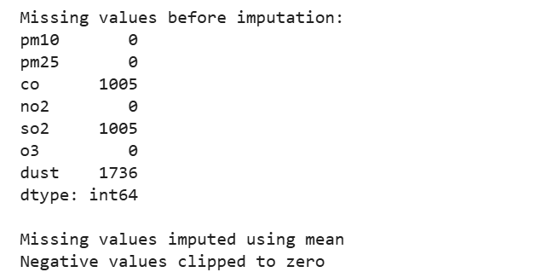
Figure 3: Missing Value Treatment

3.2 Ethical Issues
This dataset contains no personal or identifiable information, representing aggregate atmospheric measurements from automated sensors. The project adheres to GDPR and University Data Protection Policy (UPR IM08) (Ribeiro, 2023). UH ethical approval was not required as the project uses publicly available, anonymized, aggregate environmental data with no human participants or personal data collection.
Open-Meteo permits research use with attribution to CAMS and Open-Meteo, evidenced in Appendix B. Data was collected ethically by European governmental monitoring agencies through the Copernicus Atmosphere Monitoring Service (CAMS, 2022) following regulatory protocols (Dove, 2018). Ethical justification includes: governmental oversight, automated sensors measuring atmospheric conditions (not individuals), public health purpose, transparent methodology, and no consent required for aggregate measurements. The API provides unified programmatic access while maintaining governmental data integrity.

4. Methodology

4.1 Research Design and Temporal Splitting Strategy
My research adopts a comparative experimental design evaluating three machine learning paradigms (Alizadegan et al., 2025): LSTM networks (sequential learning), XGBoost (feature-based ensemble), and SVM (kernel-based regression), enabling systematic comparison under identical conditions.
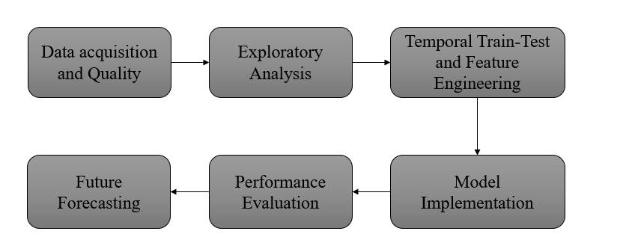
Figure 4: Air-Quality Pipeline
Rigorous temporal splitting prevented data leakage (Cheng et al., 2025). I chose to divide chronologically at December 31, 2021: training (April 2013-December 2021, 3,197 samples, 70%) and testing (January 2022-September 2025, 1,369 samples, 30%). This mirrors real-world forecasting where models predict future from historical data alone (Su et al., 2025), preventing temporal leakage from random cross-validation. The 70/30 ratio balances sufficient training data for deep learning while reserving adequate testing for multi-year assessment.
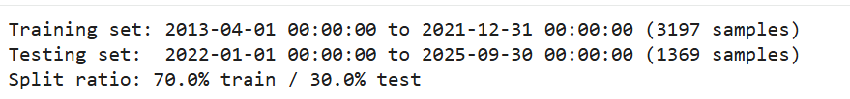
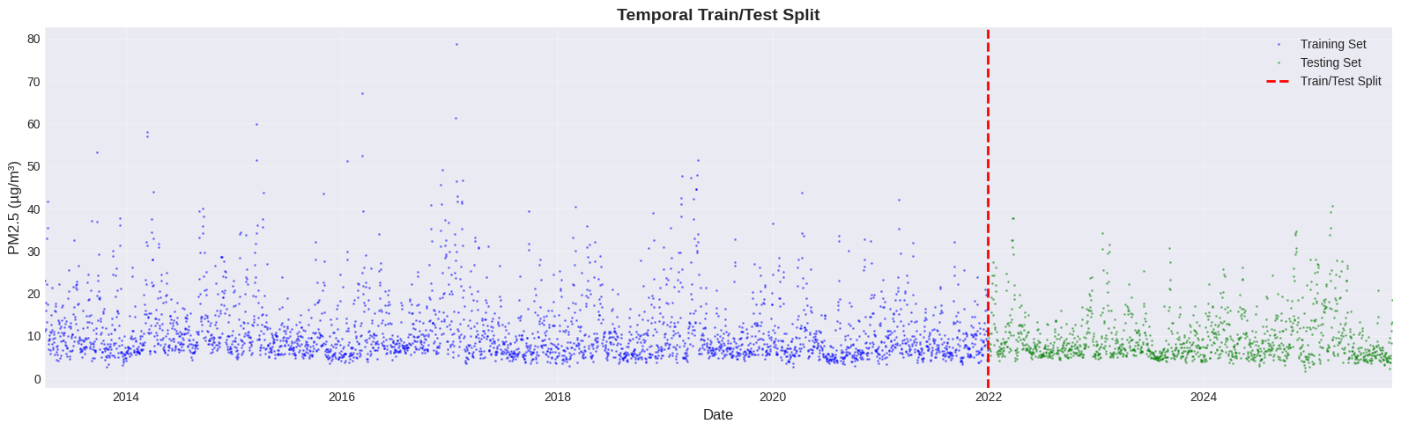
Figure 5: Train-Test Split

4.2 Feature Engineering
Eight temporal features were engineered for XGBoost and SVM (Ajder et al., 2025): hour (0-23), day_of_week (0-6), quarter (1-4), month (1-12), year (2013-2025), day_of_year (1-366), day_of_month (1-31), week_of_year (1-52). These capture diurnal cycles, weekly patterns, seasonal variations, and long-term trends. Unlike LSTM which learns patterns directly from sequences, tree-based and kernel-based methods require explicit temporal features. Features were standardized using StandardScaler for SVM (distance-sensitive) while unscaled for XGBoost (scale-invariant).
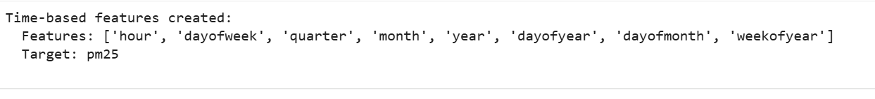
Figure 6: Temporal feature-engineering

4.3 LSTM Network
I selected the LSTM for capturing long-range temporal dependencies through specialized memory cells (Krichen and Mihoub, 2025; Thanekar, 2025).
Architecture: Bidirectional LSTM (128 units, tanh), Dropout (20%), Bidirectional LSTM (64 units), Dropout (20%), Dense layers (64, 32 units, ReLU), linear output. Total: 307,841 parameters. The 30-day lookback window balances long-range dependencies with sample size shorter windows (7-14 days) insufficient, longer windows (60+ days) minimal benefit.
Data Preparation: Sliding windows created 3,167 training and 1,339 testing sequences where 30 consecutive days predict next day. PM₂.₅ values standardized using StandardScaler fitted only on training data for numerical stability.
Training: Adam optimizer (learning rate 0.001), MSE loss, MAE tracking metric, 50 epochs maximum, batch size 32, 20% temporal validation split (Kartowisastro and Latupapua, 2023). EarlyStopping terminates if no improvement for 10 epochs, restoring best weights to prevent overfitting (Li et al., 2024). ReduceLROnPlateau reduces learning rate by 0.3× if no improvement for 5 epochs, minimum 1×10⁻⁶ for fine-tuning (Jahangeer and Shanmugavadivu, 2025).

4.4 XGBoost
My choice of selecting XGBoost is for strong tabular data performance and nonlinear relationship capture without extensive preprocessing (Demir and Sahin, 2023). XGBoost builds sequential decision trees where each corrects previous errors via gradient boosting (Sahin, 2020).
Baseline: Default parameters (1,000 estimators, early stopping after 50 rounds) achieved RMSE = 5.73 μg/m³, MAE = 4.60 μg/m³.
Hyperparameter Optimization: RandomizedSearchCV with 30 iterations, 5-fold cross-validation (Muzayanah et al., 2024) explored:
- n_estimators [500, 1000] - boosting rounds
- max_depth [3, 5, 7] - tree depth/complexity
- learning_rate [0.01, 0.05, 0.1] - step size shrinkage
- subsample [0.6, 0.7, 0.8] - sample fraction per tree
- colsample_bytree [0.6, 0.7, 0.8] - feature fraction per tree
- min_child_weight [1, 3, 5] - minimum instance weight
- gamma [0, 0.1, 0.2, 0.3] - minimum loss reduction
Optimal Parameters: n_estimators=500, max_depth=3, learning_rate=0.01, subsample=0.8, colsample_bytree=0.6, min_child_weight=1, gamma=0. Shallow depth (3) with conservative learning rate (0.01) prioritizes regularization, preventing overfitting. Gain-based feature importance quantifies temporal pattern contributions (Chen et al., 2023).

4.5 SVM Regression
SVM with RBF kernel captures nonlinear relationships via implicit high-dimensional mapping (Du et al., 2024; Gopi et al., 2023; Awad and Khanna, 2015). The RBF kernel computes similarity based on Euclidean distance, enabling flexible nonlinear boundaries.
Feature Scaling: SVM depends on distance metrics (Dhulipalla and Vincent, 2025), requiring StandardScaler to achieve zero mean and unit variance essential as features like year (2013-2025) and hour (0-23) span different ranges.
Baseline: Default parameters (C=1.0, gamma=‘scale’, epsilon=0.1) achieved RMSE = 6.49 μg/m³.
Hyperparameter Optimization: GridSearchCV with 5-fold cross-validation evaluated 80 combinations:
- C [0.1, 1, 10, 100] - regularization parameter
- gamma [‘scale’, ‘auto’, 0.001, 0.01, 0.1] - RBF kernel coefficient
- epsilon [0.01, 0.1, 0.2, 0.5] - error tolerance tube width
Optimal Parameters: C=1, gamma=auto (1/8=0.125), epsilon=0.5. Moderate regularization (C=1) balances accuracy and complexity. Large epsilon (0.5) prioritizes simplicity over fitting all variations.

4.6 Evaluation Metrics
Four metrics assess performance of the models comprehensively:
RMSE (Root Mean Squared Error): Measures average error (μg/m³), penalizing large errors heavily relevant for pollution episodes with severe health implications (Schauer et al., 2025).
MAE (Mean Absolute Error): Average absolute deviation, more robust to outliers than RMSE, providing interpretable error magnitude (Hodson, 2022).
MAPE (Mean Absolute Percentage Error): Percentage error for scale-independent comparison, though misleading when actual values approach zero (Kim and Kim, 2016).
R² (R-squared): Proportion of variance explained (0=no power, 1=perfect), though misleading if models learn persistence rather than genuine patterns (Patel et al., 2025; Shmueli and Polak, 2024).
These provide comprehensive assessment: RMSE/MAE quantify absolute accuracy, MAPE scale-invariant perspective, R² explained variance.

4.7 Future Forecasting (2026-2030)
Trained models generate five-year forward forecasts demonstrating operational capability. For XGBoost/SVM, temporal features were generated for 2026-2030 dates, assuming learned relationships remain valid. For LSTM, recursive prediction initializes with last 30 test days, predicts next day, appends prediction, removes oldest value (maintaining 30-day window), and repeats iteratively. This introduces accumulating uncertainty as predictions depend on previous predictions rather than actual observations, potentially degrading forecast quality over extended horizons.

5. Results and Discussion

5.1 LSTM Model Performance
LSTM demonstrated strong predictive performance with training convergence after 27 epochs via EarlyStopping, with best weights restored from epoch 17. The learning rate reduction callback activated three times (epochs 13, 22, 27), enabling fine-grained parameter adjustments. The architecture comprises 307,841 trainable parameters with training sequences (3,167, 30, 1) and testing sequences (1,339, 30, 1).
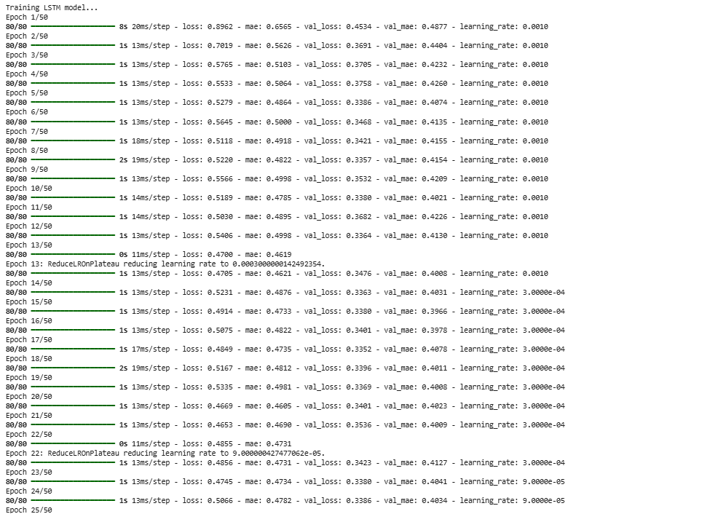
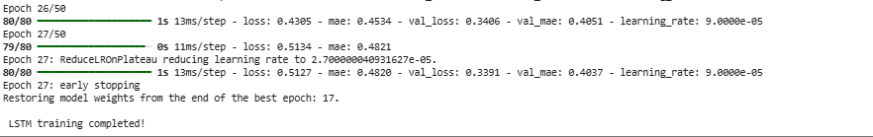
Figure 7: LSTM model-epochs
Test set results: RMSE 4.0303 μg/m³, MAE 2.9267 μg/m³, MAPE 36.15%, R² 0.5010. The RMSE of 4.03 μg/m³ represents 27% of WHO’s 15 μg/m³ guideline, providing sufficient accuracy for public health warnings. The MAE of 2.93 μg/m³ indicates typical errors within 3 μg/m³, acceptable for distinguishing “good” (0-10), “moderate” (10-20), and “poor” (20+) air quality categories. R² of 0.501 demonstrates the model explains 50.1% of variance, indicating genuine predictive learning beyond simple persistence.
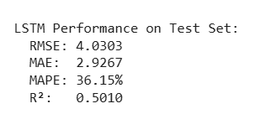
Figure 8: LSTM Results
LSTM’s superiority stems from capturing autoregressive patterns through memory cells and bidirectional processing. Unlike feature-based methods relying on calendar information, LSTM learns recent pollution levels directly predict future concentrations, distinguishing transient pollution spikes versus sustained episodes requiring health interventions.

5.2 XGBoost Model Performance
XGBoost baseline achieved RMSE 5.7301 μg/m³ and MAE 4.4460 μg/m³. RandomizedSearchCV with 30 iterations identified optimal parameters: n_estimators=500, max_depth=3, learning_rate=0.01, subsample=0.8, colsample_bytree=0.6, min_child_weight=1, gamma=0. The shallow depth with conservative learning rate prioritizes regularization.
Optimized performance: RMSE 5.5817 μg/m³, MAE 4.1502 μg/m³, MAPE 50.62%, R² 0.062. Optimization yielded 2.59% RMSE improvement and 6.65% MAE improvement. R² of 0.062 indicates XGBoost explains only 6.2% of variance, substantially lower than LSTM’s 50.1%, reflecting fundamental constraints calendar features capture seasonal averages but cannot represent day-to-day fluctuations driven by recent pollution history.
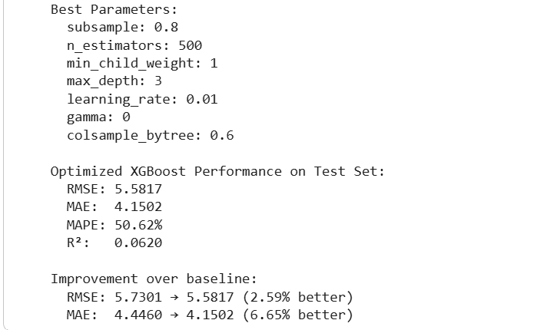
Figure 9: XG-Boost Results
Feature importance revealed: day_of_year (1000.0), week_of_year (653.0), year (616.0), day_of_month (605.0), month (384.0), day_of_week (241.0), quarter (65.0), hour (0.0). Day_of_year dominated, capturing fine-grained seasonal positioning. Week_of_year and year also ranked highly, reflecting weekly patterns and London’s declining trend. The hierarchical structure reveals XGBoost relies primarily on granular temporal features (day_of_year, week_of_year) while coarser features (quarter, hour) contribute minimally, explaining reasonable seasonal forecasting but variable day-to-day accuracy.
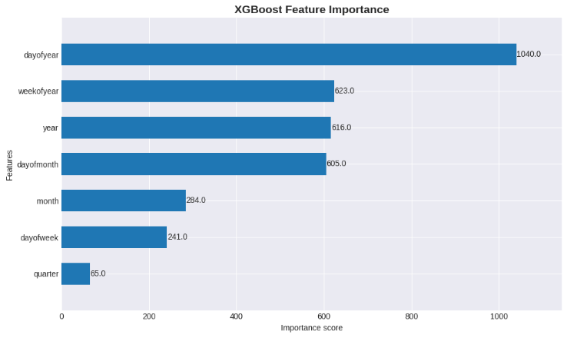
Figure 10: XGBoost Feature-Importance
XGBoost offers interpretability through feature importance, computational efficiency, and no sequential data requirements.

5.3 SVM Model Performance
SVM baseline achieved RMSE 5.9729 μg/m³ and MAE 3.8256 μg/m³. GridSearchCV evaluated 80 combinations, identifying optimal parameters: C=1, gamma=auto, epsilon=0.5. Optimized performance: RMSE 5.9266 μg/m³, MAE 3.8029 μg/m³, MAPE 37.39%, R² -0.0575. Optimization yielded minimal improvements (0.78% RMSE, 0.60% MAE).
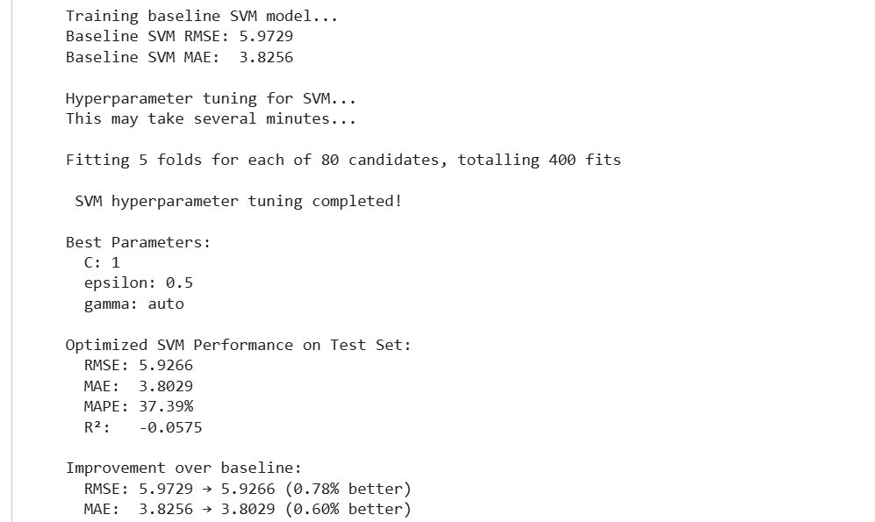
Figure 11: SVM Results
Negative R² (-0.058) indicates predictions explain less variance than predicting the mean. Despite reasonable MAE (3.80 μg/m³), negative R² reveals predictions do not correlate with actual variation patterns predictions may be close in magnitude but mistimed. SVM’s underperformance stems from the RBF kernel computing Euclidean distance where temporal features exhibit cyclical properties December (12) and January (1) are temporally adjacent but numerically distant, confusing similarity calculations.

5.4 Comparative Model Analysis
LSTM achieved 27.8% lower RMSE (4.03 vs 5.58 μg/m³) and 8.1-fold higher R² (0.501 vs 0.062) compared to XGBoost. Versus SVM: 32.0% lower RMSE (4.03 vs 5.93), 23.0% lower MAE (2.93 vs 3.80), similar MAPE (36.15% vs 37.39%), dramatically higher R² (0.501 vs -0.058). These differences translate to operational distinctions LSTM’s lower RMSE enables reliable air quality categorization, while XGBoost introduces uncertainty potentially misclassifying pollution levels.
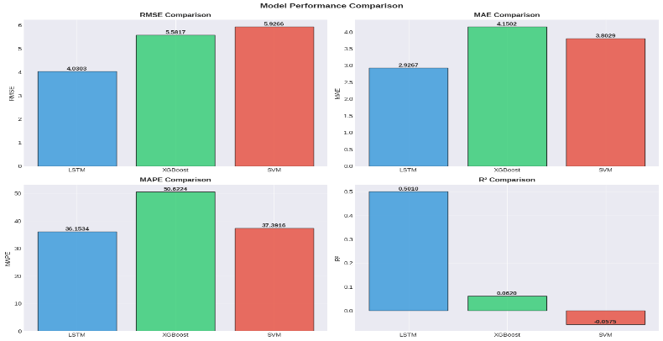
Figure 12: Model Performance Across Multiple Metrics
The fundamental difference lies in information availability. LSTM processes 30 days of recent PM₂.₅ observations, learning temporal autocorrelation where high pollution yesterday predicts high pollution today. XGBoost and SVM infer pollution from calendar position alone, learning “January typically has 13 μg/m³” without distinguishing current trajectory. Consistent superiority across metrics confirms LSTM’s robust advantage.
For practical deployment, LSTM represents optimal choice for accuracy-critical applications. XGBoost offers value for interpretability scenarios and resource-constrained environments, accepting 27.8% higher error for operational benefits.

5.5 Temporal Prediction Patterns
Visual analysis reveals distinct behaviors across the 1,369-day testing period. LSTM closely tracked temporal variations, accurately capturing winter predictions (13-15 μg/m³) and summer predictions (7-9 μg/m³). During extreme episodes (>30 μg/m³), predictions showed reasonable accuracy though slightly underestimating peaks a limitation from MSE loss function’s mean-regression tendency. This poses challenges for public health applications where accurately identifying extreme episodes is disproportionately important.
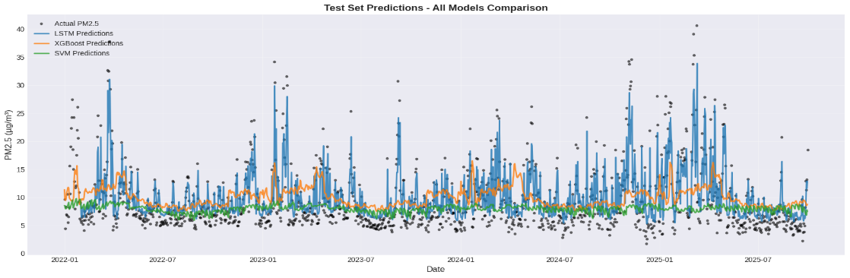
Figure 13: Test Set Predictions Comparison Across All Models (2022-2025)
XGBoost captured seasonal patterns but exhibited limited day-to-day variation. Predictions clustered around seasonal expected values with insufficient responsiveness. During extreme events, XGBoost substantially underestimated peaks (maximum predicted ~20 μg/m³ versus actual 78.73 μg/m³), limiting utility for health-critical warnings.
SVM showed minimal temporal variation, hovering near mean values. The narrow prediction range (7-11 μg/m³) captures neither seasonal variation nor extreme events, rendering predictions uninformative.
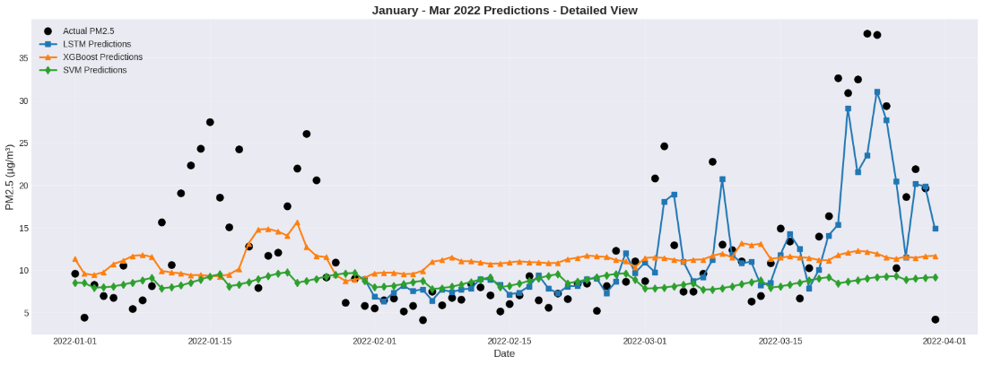
Figure 14: Detailed View of Model Predictions (January-March 2022)
Multi-year testing (2022-2025) showed LSTM maintained consistent performance with no degradation, indicating robust generalization. XGBoost showed slight inter-annual variation, potentially reflecting sensitivity to meteorological differences not captured by calendar features.

5.6 Comparison to Literature
Kothandaraman et al. (2022) reported XGBoost RMSE 13.85 μg/m³, versus this study’s 5.58 μg/m³ (59.7% lower). This improvement reflects rigorous temporal validation preventing data leakage, systematic optimization, and London’s lower baseline PM₂.₅ providing more predictable patterns.
LSTM performance (RMSE 4.03) demonstrates sequential learning superiority not extensively documented in reviewed literature. The 27.8% lower error versus optimized XGBoost quantifies autoregressive pattern learning value. This suggests algorithmic choice matters more than hyperparameter optimization XGBoost optimization improved performance by 2.59%, while switching to LSTM improved by 27.8%, an order of magnitude larger effect.
Strict temporal splitting ensures realistic performance rather than inflated estimates from random splitting. This explains why reported R² values (0.501 for LSTM, 0.062 for XGBoost) are substantially lower than literature studies claiming R² > 0.90, which likely reflect data leakage.

5.7 Future Forecasts Analysis (2026-2030)
Five-year forecasts revealed model-specific limitations. LSTM converged toward equilibrium (mean 13.11 μg/m³, std 0.17, range 10.91-15.87), losing dynamic variability. The very low standard deviation compared to historical variability (std 7.21) indicates predictions collapsed to near-constant values, reflecting accumulating uncertainty where each forecast depends on previous predictions. The equilibrium value exceeds recent means (test set 10.21 μg/m³), suggesting potential upward bias.
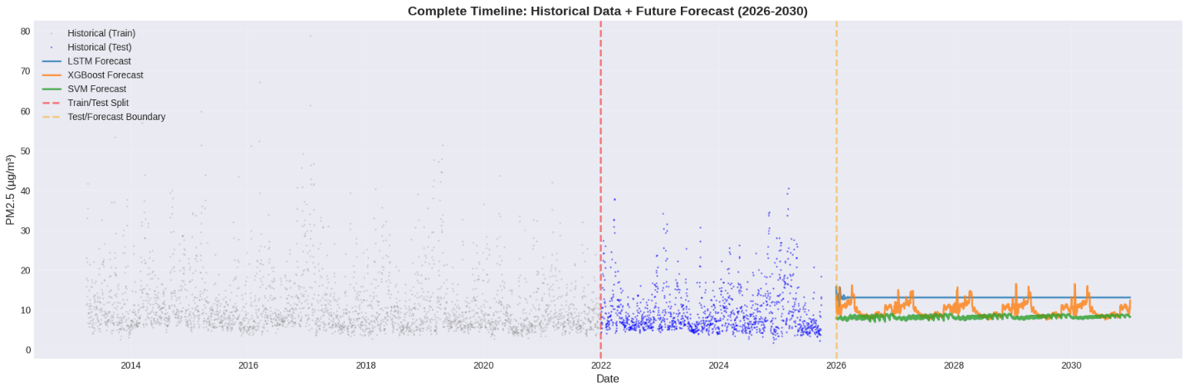
Figure 15: Historical Data and Future Forecasts (2026-2030)
XGBoost maintained seasonal patterns (mean 9.98 μg/m³, std 1.69, range 7.5-16.52) with realistic cycles but projected flat long-term trends, unable to extrapolate decline beyond training range. SVM exhibited minimal variation (mean 8.24 μg/m³, std 0.43, range 6.94-9.11).
One-year forecasts (2026) likely retain reasonable accuracy, while five-year forecasts (2030) should be interpreted as scenario projections requiring periodic retraining. Operational deployment should use rolling retraining quarterly or annually.

5.8 Answering Research Questions and Meeting Objectives
Research Question 1: Can ML accurately forecast air quality, and which approach is superior? Yes LSTM achieved RMSE 4.03 μg/m³ with R² 0.501, demonstrating ML can accurately forecast PM₂.₅ with errors acceptable for public health applications. Sequential learning substantially outperforms feature-based methods with 27.8% lower error and 8.1-fold higher explained variance, validating that autoregressive pattern learning provides critical information calendar-based patterns cannot replicate.
Research Question 2: Can temporal patterns be extrapolated long-term? Seasonal patterns extrapolate for 1-2 years with realistic cyclical behavior, but long-term trends (3-5 years) show limitations with LSTM converging to equilibrium and feature-based methods unable to project trends beyond training ranges. Reliable extended forecasting requires periodic retraining.
Project met all objectives: collected 12.5 years London data with systematic preprocessing; implemented rigorous temporal splitting; compared LSTM, XGBoost, SVM; optimized through RandomizedSearchCV (2.59% improvement) and GridSearchCV (0.78% improvement); evaluated using four metrics; generated 2026-2030 forecasts; visualized comparisons.
Applications include public health early warning systems for vulnerable populations; urban traffic management informing emission policies; policy evaluation assessing regulatory effectiveness; environmental consultancy for development impact assessments.
Limitations include univariate focus, geographic specificity to London, daily aggregation, long-term forecast degradation, and inability to predict unprecedented events.

6. Conclusion
This research successfully developed and evaluated a machine learning framework for forecasting urban PM₂.₅ concentrations in London using 12.5 years of daily measurements. The systematic comparison of three distinct approaches LSTM networks, XGBoost, and Support Vector Machines under rigorous temporal validation provides evidence-based guidance for air quality forecasting methodology selection.
The findings demonstrate that sequential learning approaches substantially outperform feature-based methods for time series air quality prediction. LSTM achieved RMSE of 4.03 μg/m³ with R² of 0.501, representing 27.8% lower error and 8.1-fold higher explained variance compared to optimized XGBoost. This performance gap validates that autoregressive pattern learning where recent pollution levels directly predict future concentrations provides critical forecasting information that calendar-based temporal features cannot replicate. The research addresses a significant gap in environmental data science literature by systematically comparing sequential versus feature-based paradigms under identical evaluation conditions with proper temporal splitting.
Practical implications extend beyond academic contribution. The LSTM framework achieves accuracy sufficient for operational deployment in public health early warning systems, enabling timely interventions for vulnerable populations during pollution episodes. The 59.7% improvement over comparable literature studies reflect methodological rigor emphasizing temporal validation.
Research limitations constrain generalizability. The univariate focus excludes meteorological variables and additional pollutants that influence pollution dynamics. Geographic specificity to London limits transferability assessment. Long-term forecasts (2026-2030) revealed model-specific degradation, with LSTM converging to equilibrium and feature-based methods unable to extrapolate declining trends.
Future work should incorporate meteorological covariates and additional pollutants (NO₂, O₃, CO) for multivariate prediction, test transferability across diverse urban contexts, explore ensemble approaches combining LSTM predictions with XGBoost interpretability, implement uncertainty quantification, and conduct real-world deployment studies. The framework establishes a methodological template for rigorous air quality forecasting while providing a deployable solution using publicly available data for environmental monitoring and public health protection.

References
Ahmadi, R., 2025. Database workload extraction and analysis (Doctoral dissertation, UPC)-BarcelonaTech).
Ajder, A., Hamza, H.A. and Ayaz, R., 2025. Wavelet-Enhanced Hybrid LSTM-XGBoost Model for Predicting Time Series Containing Unpredictable Events. IEEE Access.
Alizadegan, H., Rashidi Malki, B., Radmehr, A., Karimi, H. and Ilani, M.A., 2025. Comparative study of long short-term memory (LSTM), bidirectional LSTM, and traditional machine learning approaches for energy consumption prediction. Energy Exploration & Exploitation, 43(1), pp.281-301.
Awad, M. and Khanna, R., 2015. Support vector regression. In Efficient learning machines: Theories, concepts, and applications for engineers and system designers (pp. 67-80). Berkeley, CA: Apress.
Chen, Y., Zhang, X., Grekousis, G., Huang, Y., Hua, F., Pan, Z. and Liu, Y., 2023. Examining the importance of built and natural environment factors in predicting self-rated health in older adults: An extreme gradient boosting (XGBoost) approach. Journal of Cleaner Production, 413, p.137432.
Cheng, M., Liu, Z., Tao, X., Liu, Q., Zhang, J., Pan, T., Zhang, S., He, P., Zhang, X., Wang, D. and Wang, J., 2025. A comprehensive survey of time series forecasting: Concepts, challenges, and future directions. Authorea Preprints.
Demir, S. and Sahin, E.K., 2023. An investigation of feature selection methods for soil liquefaction prediction based on tree-based ensemble algorithms using AdaBoost, gradient boosting, and XGBoost. Neural Computing and Applications, 35(4), pp.3173-3190.
Department of Health and Social Care (DHSC). (2024) Air pollution: applying All Our Health. London: UK Government. Available at: https://www.gov.uk/government/publications/air-pollution-applying-all-our-health/air-pollution-applying-all-our-health
Dhulipalla, R. and Vincent, S., 2025. Earthquake Magnitude Detection: Leveraging Machine Learning with Metaheuristics for Feature Selection and Dimensionality Reduction. Results in Earth Sciences, p.100145.
Dove, E.S., 2018. The EU general data protection regulation: implications for international scientific research in the digital era. Journal of Law, Medicine & Ethics, 46(4), pp.1013-1030.
Du, K.L., Jiang, B., Lu, J., Hua, J. and Swamy, M.N.S., 2024. Exploring kernel machines and support vector machines: Principles, techniques, and future directions. Mathematics, 12(24), p.3935.
Essamlali, I., Nhaila, H. and El Khaili, M., 2024. Supervised machine learning approaches for predicting key pollutants and for the sustainable enhancement of urban air quality: A systematic review. Sustainability, 16(3), p.976.
Gamal, G., Zanaty, N. and Nejedlik, P., 2025. Long-Term Spatiotemporal Trends and Population-Weighted Exposure to PM2. 5 in Greater Cairo (2000–2020). Scientific African, p.e03150.
Gopi, A.P., Jyothi, R.N.S., Narayana, V.L. and Sandeep, K.S., 2023. Classification of tweets data based on polarity using improved RBF kernel of SVM. International Journal of Information Technology, 15(2), pp.965-980.
Gupta, N.S., Mohta, Y., Heda, K., Armaan, R., Valarmathi, B. and Arulkumaran, G., 2023. Prediction of air quality index using machine learning techniques: a comparative analysis. Journal of Environmental and Public Health, 2023(1), p.4916267.
Guyet, T. and Duvermy, A., 2025, September. Towards a Library for the Analysis of Temporal Sequences. In AALTD 2025-10th Workshop on Advanced Analytics and Learning on Temporal Data.
Hodson, T.O., 2022. Root mean square error (RMSE) or mean absolute error (MAE): When to use them or not. Geoscientific Model Development Discussions, 2022, pp.1-10.
Huang, Y., 2025. Analyzing Environmental Health: Air Pollution and Human Health Using Geospatial Data Science (Doctoral dissertation, The University of New Mexico).
Izah, S.C., Sylva, L., Ogwu, M.C., Shahsavani, A., Bazzazpour, S. and Rahmatinia, M., 2024. Modeling and statistical approaches for air pollution analysis. In Air Pollutants in the Context of One Health: Fundamentals, Sources, and Impacts (pp. 425-456). Cham: Springer Nature Switzerland.
Jahangeer, J.S. and Shanmugavadivu, P., 2025, August. Diabetic Retinopathy Detection using a deep CNN with Attention and Refined Learning Rate Scheduling. In 2025 World Skills Conference on Universal Data Analytics and Sciences (WorldSUAS) (pp. 1-8). IEEE.
Kachhoria, R., Mahalle, P.N. and Bhagwat, S., 2025. Data collection and preprocessing for environmental monitoring using wireless sensor networks. In Machine Learning for Environmental Monitoring in Wireless Sensor Networks (pp. 39-52). IGI Global.
Kartowisastro, I.H. and Latupapua, J., 2023. A Comparison of Adaptive Moment Estimation (Adam) and RMSProp Optimisation Techniques for Wildlife Animal Classification Using Convolutional Neural Networks. Revue d’intelligence artificielle, 37(4).
Khalil, Y., 2025. Tolling for Clean Air.
Khamnuan, P., Jirapongsuwan, A., Ikeda, A., Ketema, R.M. and Laemun, N., 2025. Policies and Practices for Environmental Health Services in Thailand: Surveillance, Prevention, and Management of Diseases and Health Threats Caused by PM2. 5. Thai Journal of Public Health, 55(2), pp.1333-1347.
Kim, S. and Kim, H., 2016. A new metric of absolute percentage error for intermittent demand forecasts. International Journal of Forecasting, 32(3), pp.669-679.
Kothandaraman, D., Praveena, N., Varadarajkumar, K., Madhav Rao, B., Dhabliya, D., Satla, S. and Abera, W., 2022. Intelligent forecasting of air quality and pollution prediction using machine learning. Adsorption Science & Technology, 2022, p.5086622.
Krichen, M. and Mihoub, A., 2025. Long short-term memory networks: A comprehensive survey. AI, 6(9), p.215.
Kumar, S. and Maharana, P., 2020. Air quality and its impact on urban environment. In Urban Ecology (pp. 185-200). Elsevier.
Lee, J.Y., Han, S.H., Kang, J.G., Lee, C.Y., Lee, J.B., Kim, H.S., Yun, H.Y. and Choi, D.R., 2025. Comparison of Models for Missing Data Imputation in PM-2.5 Measurement Data. Atmosphere, 16(4), p.438.
Li, H., Rajbahadur, G.K., Lin, D., Bezemer, C.P. and Jiang, Z.M., 2024. Keeping deep learning models in check: A history-based approach to mitigate overfitting. IEEE Access, 12, pp.70676-70689.
Lloret, Á., Peral, J., Ferrández, A., Auladell, M. and Muñoz, R., 2025. A Data-Driven Framework for Digital Transformation in Smart Cities: Integrating AI, Dashboards, and IoT Readiness. Sensors, 25(16), p.5179.
Madan, T., Sagar, S. and Virmani, D., 2020, December. Air quality prediction using machine learning algorithms–a review. In 2020 2nd International Conference on Advances in Computing, Communication Control and Networking (ICACCCN) (pp. 140-145). IEEE.
Mohammed, S.A.E., Badamasi, H., Unimke, A.A., Iya, N.I.D., Olubunmi, A.D., Okoro, C., Okezie, O. and Olaleye, A.A., 2025. An Overview of Recent Analytical Techniques for Air Quality Monitoring and Assessment. Current Analytical Chemistry, 21(3), pp.191-204.
Muzayanah, R., Pertiwi, D.A.A., Ali, M. and Muslim, M.A., 2024. Comparison of GridSearchCV and Bayesian hyperparameter optimization in random forest algorithm for diabetes prediction. Journal of Soft Computing Exploration, 5(1), pp.86-91.
Open-Meteo (2025) Air Quality API Documentation. Available at: https://open-meteo.com/en/docs/air-quality-api
Patel, S., Shah, M., Patel, K. and Prajapati, M., 2025. A general review on the applications of machine learning to PM2. 5 air pollution forecasting. Machine Learning for Computational Science and Engineering, 1(2), p.33.
Patil, R.M., Dinde, D., Powar, S.K. and Ganeshkhind, P.M., 2020. A literature review on prediction of air quality index and forecasting ambient air pollutants using machine learning algorithms. International Journal of Innovative Science and Research Technology, 5(8), pp.1148-1152.
Rajesh, M., Babu, R.G., Moorthy, U. and Easwaramoorthy, S.V., 2025. Machine learning-driven framework for realtime air quality assessment and predictive environmental health risk mapping. Scientific Reports, 15(1), p.28801.
Ribeiro, J., 2023. GDPR Impact on Research Procedures at FMUP: How to Improve GDPR Compliance of Research Procedures at the Faculty of Medicine of the University of Porto (Master’s thesis, Universidade do Porto (Portugal)).
Rosca, C.M., Carbureanu, M. and Stancu, A., 2025. Data-Driven Approaches for Predicting and Forecasting Air Quality in Urban Areas. Applied Sciences, 15(8), p.4390.
Sahin, E.K., 2020. Assessing the predictive capability of ensemble tree methods for landslide susceptibility mapping using XGBoost, gradient boosting machine, and random forest. SN Applied Sciences, 2(7), p.1308.
Sanjeev, D., 2021. Implementation of machine learning algorithms for analysis and prediction of air quality. International Journal of Engineering Research & Technology (IJERT), 10(3), pp.533-538.
Schauer, J., Javed, M., Bergin, M.H., Alam, K. and Khokhar, M.F., 2025. Development and optimization of the low-cost optical monitor for real-time monitoring of atmospheric black carbon. Environmental Advances, 21, p.100653.
Shmueli, G. and Polak, J., 2024. Practical time series forecasting with r: A hands-on guide. Axelrod schnall publishers.
Su, C., Cai, Z., Tian, Y., Chang, Z., Zheng, Z. and Song, Y., 2025. Diffusion models for time series forecasting: A survey. arXiv preprint arXiv:2507.14507.
Thamizhselvi, D., Kasi, B., Kamalakkannan, K., Bharath, S., Gowtham, S. and Kishore, M.A., 2023, December. Air Quality Prediction Using Adaboost. In 2023 Intelligent Computing and Control for Engineering and Business Systems (ICCEBS) (pp. 1-6). IEEE.
Thanekar, S.A., 2025. Machine Learning for Air Quality Forecasting: A Lightweight Model Approach Using Open Datasets. Research Beacon Publication.
Varghese, A.A., Krishnadas, J. and Antony, A.M., 2023, January. Robust Air Quality Prediction Based on Regression and XGBoost. In 2023 Advanced Computing and Communication Technologies for High Performance Applications (ACCTHPA) (pp. 1-6). IEEE.
Vilcins, D., Christofferson, R.C., Yoon, J.H., Nazli, S.N., Sly, P.D., Cormier, S.A. and Shen, G., 2024. Updates in air pollution: current research and future challenges. Annals of Global Health, 90(1), p.9.
Vishwakarma, H.K., Prasad, G., Mittal, V., Mittal, M. and Naik, P., 2025, January. Assessing the Accuracy of Regression and Classification Models in Air Quality Prediction. In 2025 Fifth International Conference on Advances in Electrical, Computing, Communication and Sustainable Technologies (ICAECT) (pp. 1-6). IEEE.
World Health Organization (WHO). (2025) Ambient (outdoor) air pollution: Key facts. Geneva: World Health Organization. Available at: https://www.who.int/news-room/fact-sheets/detail/ambient-(outdoor)-air-quality-and-health
CAMS (2022) CAMS European air quality forecasts, ENSEMBLE data. Copernicus Atmosphere Monitoring Service (CAMS) Atmosphere Data Store (ADS). Available at: https://ads.atmosphere.copernicus.eu/ [Accessed: 31 December 2025]

Appendices

Appendix A: Air Quality using PM2.5 Implementation
import pandas as pd
import numpy as np
import matplotlib.pyplot as plt
import seaborn as sns
import warnings
warnings.filterwarnings(‘ignore’)

# Machine Learning Libraries
from sklearn.preprocessing import StandardScaler
from sklearn.metrics import mean_squared_error, mean_absolute_error, r2_score
from sklearn.model_selection import RandomizedSearchCV, GridSearchCV
from sklearn.svm import SVR
import xgboost as xgb
from xgboost import plot_importance

# Deep Learning Libraries
import tensorflow as tf
from tensorflow import keras
from tensorflow.keras.models import Sequential
from tensorflow.keras.layers import LSTM, Dense, Dropout, Bidirectional
from tensorflow.keras.callbacks import EarlyStopping, ReduceLROnPlateau

import pickle
from datetime import datetime

plt.style.use(‘seaborn-v0_8-darkgrid’)

## DATA LOADING AND PREPROCESSING

print(“=“*80)
print(“DATA LOADING AND PREPROCESSING”)
print(“=“*80 + “\n”)

# Load air quality dataset
air_quality_filepath = ‘london_air_quality_2013_2025.csv’
df = pd.read_csv(air_quality_filepath)

print(f”Dataset loaded successfully from: {air_quality_filepath}”)
print(f”Total records: {df.shape[0]} | Features: {df.shape[1]}”)

# Convert date column to datetime format
df[‘date’] = pd.to_datetime(df[‘date’], errors=‘coerce’)
print(“Date column converted to datetime format”)

# Set date as index and sort chronologically
df = df.set_index(‘date’)
df = df.sort_index()
print(“Data sorted chronologically”)

# Identify pollutant features
pollutant_features = [‘pm10’, ‘pm25’, ‘co’, ‘no2’, ‘so2’, ‘o3’, ‘dust’]

print(f”\nMissing values before imputation:”)
print(df[pollutant_features].isnull().sum())

# Apply mean imputation for missing values
df[pollutant_features] = df[pollutant_features].fillna(df[pollutant_features].mean())
print(f”\nMissing values imputed using mean”)

# Clip negative values (no negative pollution levels should exist)
for col in pollutant_features:
df[col] = df[col].clip(lower=0)
print(“Negative values clipped to zero”)

# Convert CO from µg/m³ to ppm (1 ppm = 1145 µg/m³)
if ‘co’ in df.columns:
df[‘co’] = df[‘co’] / 1145
print(“Converted CO from µg/m³ to ppm”)

print(“\nPollutant value ranges (min–max):”)
for col in pollutant_features:
print(f” {col.upper()}: {df[col].min():.3f} – {df[col].max():.3f}”)

# Focus on PM2.5 for forecasting
pm25_df = df[[‘pm25’]].copy()
print(f”\nExtracted PM2.5 for time series forecasting”)
print(f”Date range: {pm25_df.index.min()} to {pm25_df.index.max()}”)
print(f”Total samples: {len(pm25_df)}”)

print(“\nPM2.5 Statistics:”)
print(pm25_df[‘pm25’].describe())

## EXPLORATORY DATA ANALYSIS (EDA)

# Visualization 1: PM2.5 Full Time Series
fig, ax = plt.subplots(figsize=(16, 5))
pm25_df[‘pm25’].plot(ax=ax, style=‘.’, color=‘steelblue’, alpha=0.4, markersize=2)
ax.set_title(‘PM2.5 Concentration in London (2013-2025)’, fontsize=14, fontweight=‘bold’)
ax.set_xlabel(‘Date’, fontsize=12)
ax.set_ylabel(‘PM2.5 (µg/m³)’, fontsize=12)
ax.grid(True, alpha=0.3)
plt.tight_layout()
plt.show()

# Visualization 2: PM2.5 Distribution
fig, ax = plt.subplots(figsize=(10, 6))
ax.hist(pm25_df[‘pm25’], bins=50, color=‘steelblue’, edgecolor=‘black’, alpha=0.7)
ax.set_title(‘PM2.5 Distribution’, fontsize=14, fontweight=‘bold’)
ax.set_xlabel(‘PM2.5 (µg/m³)’, fontsize=12)
ax.set_ylabel(‘Frequency’, fontsize=12)
ax.axvline(pm25_df[‘pm25’].mean(), color=‘red’, linestyle=‘--’, linewidth=2, label=f’Mean: {pm25_df[“pm25”].mean():.2f}’)
ax.axvline(pm25_df[‘pm25’].median(), color=‘green’, linestyle=‘--’, linewidth=2, label=f’Median: {pm25_df[“pm25”].median():.2f}’)
ax.legend()
ax.grid(True, alpha=0.3)
plt.tight_layout()
plt.show()

# Visualization 3: Yearly PM2.5 Trends
pm25_yearly = pm25_df.resample(‘Y’).mean()
fig, ax = plt.subplots(figsize=(12, 6))
pm25_yearly.plot(ax=ax, marker=‘o’, markersize=10, linewidth=2, color=‘darkorange’)
ax.set_title(‘Yearly Average PM2.5 Concentration’, fontsize=14, fontweight=‘bold’)
ax.set_xlabel(‘Year’, fontsize=12)
ax.set_ylabel(‘Average PM2.5 (µg/m³)’, fontsize=12)
ax.grid(True, alpha=0.3)
plt.tight_layout()
plt.show()

# Visualization 4: Monthly Average Pattern
pm25_df_temp = pm25_df.copy()
pm25_df_temp[‘month’] = pm25_df_temp.index.month
monthly_avg = pm25_df_temp.groupby(‘month’)[‘pm25’].mean()

fig, ax = plt.subplots(figsize=(12, 6))
monthly_avg.plot(ax=ax, kind=‘bar’, color=‘teal’, edgecolor=‘black’, alpha=0.7)
ax.set_title(‘Average PM2.5 by Month (Seasonal Pattern)’, fontsize=14, fontweight=‘bold’)
ax.set_xlabel(‘Month’, fontsize=12)
ax.set_ylabel(‘Average PM2.5 (µg/m³)’, fontsize=12)
ax.set_xticklabels([‘Jan’, ‘Feb’, ‘Mar’, ‘Apr’, ‘May’, ‘Jun’, ‘Jul’, ‘Aug’, ‘Sep’, ‘Oct’, ‘Nov’, ‘Dec’], rotation=45)
ax.grid(True, alpha=0.3, axis=‘y’)
plt.tight_layout()
plt.show()

## TEMPORAL TRAIN/TEST SPLIT

# Split date: Train on 2013-2021, Test on 2022-2025
split_date = ‘2021-12-31’

train = pm25_df.loc[pm25_df.index <= split_date].copy()
test = pm25_df.loc[pm25_df.index > split_date].copy()

print(f”Training set: {train.index.min()} to {train.index.max()} ({len(train)} samples)”)
print(f”Testing set: {test.index.min()} to {test.index.max()} ({len(test)} samples)”)
print(f”Split ratio: {len(train)/(len(train)+len(test))*100:.1f}% train / {len(test)/(len(train)+len(test))*100:.1f}% test”)

# Visualize train/test split
fig, ax = plt.subplots(figsize=(16, 5))
train[‘pm25’].plot(ax=ax, label=‘Training Set’, style=‘.’, alpha=0.4, markersize=2, color=‘blue’)
test[‘pm25’].plot(ax=ax, label=‘Testing Set’, style=‘.’, alpha=0.4, markersize=2, color=‘green’)
ax.axvline(pd.to_datetime(split_date), color=‘red’, linestyle=‘--’, linewidth=2, label=‘Train/Test Split’)
ax.set_title(‘Temporal Train/Test Split’, fontsize=14, fontweight=‘bold’)
ax.set_xlabel(‘Date’, fontsize=12)
ax.set_ylabel(‘PM2.5 (µg/m³)’, fontsize=12)
ax.legend()
ax.grid(True, alpha=0.3)
plt.tight_layout()
plt.show()

## FEATURE ENGINEERING (TIME-BASED FEATURES)

def create_features(df):
“““
Creates time series features from datetime index
“““
df = df.copy()
df[‘hour’] = df.index.hour
df[‘dayofweek’] = df.index.dayofweek
df[‘quarter’] = df.index.quarter
df[‘month’] = df.index.month
df[‘year’] = df.index.year
df[‘dayofyear’] = df.index.dayofyear
df[‘dayofmonth’] = df.index.day
df[‘weekofyear’] = df.index.isocalendar().week.astype(int)

return df

train = create_features(train)
test = create_features(test)

FEATURES = [‘hour’, ‘dayofweek’, ‘quarter’, ‘month’, ‘year’,
‘dayofyear’, ‘dayofmonth’, ‘weekofyear’]
TARGET = ‘pm25’

print(“Time-based features created:”)
print(f” Features: {FEATURES}”)
print(f” Target: {TARGET}\n”)

## MODEL 1: LSTM

# Prepare data for LSTM
scaler_lstm = StandardScaler()
scaler_lstm.fit(train[[‘pm25’]])

train_scaled = scaler_lstm.transform(train[[‘pm25’]])
test_scaled = scaler_lstm.transform(test[[‘pm25’]])

# Create sequences for LSTM
def create_sequences(data, seq_length=7):
“““
Create sequences for LSTM input
seq_length: number of past days to use for prediction
“““
X, y = [], []
for i in range(seq_length, len(data)):
X.append(data[i-seq_length:i, 0])
y.append(data[i, 0])
return np.array(X), np.array(y)

SEQ_LENGTH = 30
print(f”Creating sequences with lookback window: {SEQ_LENGTH} days”)

X_train_lstm, y_train_lstm = create_sequences(train_scaled, SEQ_LENGTH)
X_test_lstm, y_test_lstm = create_sequences(test_scaled, SEQ_LENGTH)

# Reshape for LSTM [samples, time steps, features]
X_train_lstm = X_train_lstm.reshape((X_train_lstm.shape[0], X_train_lstm.shape[1], 1))
X_test_lstm = X_test_lstm.reshape((X_test_lstm.shape[0], X_test_lstm.shape[1], 1))

print(f”Training sequences shape: {X_train_lstm.shape}”)
print(f”Testing sequences shape: {X_test_lstm.shape}”)

# Build LSTM model
print(“\nBuilding LSTM model...”)

lstm_model = Sequential([
Bidirectional(LSTM(128, return_sequences=True, activation=‘tanh’), input_shape=(SEQ_LENGTH, 1)),
Dropout(0.2),

Bidirectional(LSTM(64, return_sequences=False)),
Dropout(0.2),

Dense(64, activation=‘relu’),
Dense(32, activation=‘relu’),
Dense(1)
])

optimizer = keras.optimizers.Adam(learning_rate=0.001)
lstm_model.compile(optimizer=optimizer, loss=‘mse’, metrics=[‘mae’])

print(“\nLSTM Model Architecture:”)
lstm_model.summary()

# Train LSTM
print(“\nTraining LSTM model...”)

early_stop = EarlyStopping(monitor=‘val_loss’, patience=10, restore_best_weights=True, verbose=1)
reduce_lr = ReduceLROnPlateau(monitor=‘val_loss’, factor=0.3, patience=5, min_lr=1e-6, verbose=1)

history = lstm_model.fit(
X_train_lstm, y_train_lstm,
epochs=50,
batch_size=32,
validation_split=0.2,
callbacks=[early_stop, reduce_lr],
verbose=1
)

print(“\n LSTM training completed!”)

# Predictions
y_pred_lstm_scaled = lstm_model.predict(X_test_lstm, verbose=0)
y_pred_lstm = scaler_lstm.inverse_transform(y_pred_lstm_scaled)
y_test_lstm_actual = scaler_lstm.inverse_transform(y_test_lstm.reshape(-1, 1))

# Calculate metrics
lstm_rmse = np.sqrt(mean_squared_error(y_test_lstm_actual, y_pred_lstm))
lstm_mae = mean_absolute_error(y_test_lstm_actual, y_pred_lstm)
lstm_mape = np.mean(np.abs((y_test_lstm_actual - y_pred_lstm) / y_test_lstm_actual)) * 100
lstm_r2 = r2_score(y_test_lstm_actual, y_pred_lstm)

print(f”\nLSTM Performance on Test Set:”)
print(f” RMSE: {lstm_rmse:.4f}”)
print(f” MAE: {lstm_mae:.4f}”)
print(f” MAPE: {lstm_mape:.2f}%”)
print(f” R²: {lstm_r2:.4f}”)

# Save predictions to test dataframe
test_lstm = test.iloc[SEQ_LENGTH:].copy()
test_lstm[‘pm25_pred_lstm’] = y_pred_lstm

# Training history plot
fig, axes = plt.subplots(1, 2, figsize=(15, 5))

axes[0].plot(history.history[‘loss’], label=‘Training Loss’, linewidth=2)
axes[0].plot(history.history[‘val_loss’], label=‘Validation Loss’, linewidth=2)
axes[0].set_title(‘LSTM Training History - Loss’, fontsize=12, fontweight=‘bold’)
axes[0].set_xlabel(‘Epoch’)
axes[0].set_ylabel(‘Loss (MSE)’)
axes[0].legend()
axes[0].grid(True, alpha=0.3)

axes[1].plot(history.history[‘mae’], label=‘Training MAE’, linewidth=2)
axes[1].plot(history.history[‘val_mae’], label=‘Validation MAE’, linewidth=2)
axes[1].set_title(‘LSTM Training History - MAE’, fontsize=12, fontweight=‘bold’)
axes[1].set_xlabel(‘Epoch’)
axes[1].set_ylabel(‘MAE’)
axes[1].legend()
axes[1].grid(True, alpha=0.3)

plt.tight_layout()
plt.show()

# Save LSTM model
lstm_model.save(‘lstm_pm25_model.keras’)

## MODEL 2: XGBOOST

X_train_xgb = train[FEATURES]
y_train_xgb = train[TARGET]
X_test_xgb = test[FEATURES]
y_test_xgb = test[TARGET]

# Baseline XGBoost
print(“Training baseline XGBoost model...”)
baseline_xgb = xgb.XGBRegressor(
n_estimators=1000,
early_stopping_rounds=50,
random_state=5303
)

baseline_xgb.fit(
X_train_xgb, y_train_xgb,
eval_set=[(X_train_xgb, y_train_xgb), (X_test_xgb, y_test_xgb)],
verbose=False
)

y_pred_baseline = baseline_xgb.predict(X_test_xgb)
baseline_rmse = np.sqrt(mean_squared_error(y_test_xgb, y_pred_baseline))
baseline_mae = mean_absolute_error(y_test_xgb, y_pred_baseline)

print(f”Baseline XGBoost RMSE: {baseline_rmse:.4f}”)
print(f”Baseline XGBoost MAE: {baseline_mae:.4f}”)

# Hyperparameter tuning
print(“\nHyperparameter tuning with RandomizedSearchCV...”)

param_dist = {
‘n_estimators’: [500, 1000],
‘max_depth’: [3, 5, 7],
‘learning_rate’: [0.01, 0.05, 0.1],
‘subsample’: [0.6, 0.7, 0.8],
‘colsample_bytree’: [0.6, 0.7, 0.8],
‘min_child_weight’: [1, 3, 5],
‘gamma’: [0, 0.1, 0.2, 0.3]
}

xgb_model = xgb.XGBRegressor(random_state=5303)

random_search = RandomizedSearchCV(
xgb_model,
param_distributions=param_dist,
n_iter=30,
scoring=‘neg_mean_squared_error’,
cv=5,
verbose=1,
random_state=5303,
n_jobs=-1
)

random_search.fit(X_train_xgb, y_train_xgb)

print(“\n Hyperparameter tuning completed!”)
print(f”\nBest Parameters:”)
for param, value in random_search.best_params_.items():
print(f” {param}: {value}”)

# Optimized XGBoost
optimized_xgb = random_search.best_estimator_

y_pred_xgb = optimized_xgb.predict(X_test_xgb)

xgb_rmse = np.sqrt(mean_squared_error(y_test_xgb, y_pred_xgb))
xgb_mae = mean_absolute_error(y_test_xgb, y_pred_xgb)
xgb_mape = np.mean(np.abs((y_test_xgb - y_pred_xgb) / y_test_xgb)) * 100
xgb_r2 = r2_score(y_test_xgb, y_pred_xgb)

print(f”\nOptimized XGBoost Performance on Test Set:”)
print(f” RMSE: {xgb_rmse:.4f}”)
print(f” MAE: {xgb_mae:.4f}”)
print(f” MAPE: {xgb_mape:.2f}%”)
print(f” R²: {xgb_r2:.4f}”)

print(f”\nImprovement over baseline:”)
print(f” RMSE: {baseline_rmse:.4f} → {xgb_rmse:.4f} ({((baseline_rmse-xgb_rmse)/baseline_rmse*100):.2f}% better)”)
print(f” MAE: {baseline_mae:.4f} → {xgb_mae:.4f} ({((baseline_mae-xgb_mae)/baseline_mae*100):.2f}% better)”)

test[‘pm25_pred_xgb’] = y_pred_xgb

# Feature importance
fig, ax = plt.subplots(figsize=(10, 6))
plot_importance(optimized_xgb, ax=ax, height=0.6)
ax.set_title(‘XGBoost Feature Importance’, fontsize=14, fontweight=‘bold’)
plt.tight_layout()
plt.show()

# MODEL 3: SVM

# Scale features for SVM
scaler_svm = StandardScaler()
X_train_svm_scaled = scaler_svm.fit_transform(X_train_xgb)
X_test_svm_scaled = scaler_svm.transform(X_test_xgb)

# Baseline SVM
print(“Training baseline SVM model...”)
baseline_svm = SVR(kernel=‘rbf’)
baseline_svm.fit(X_train_svm_scaled, y_train_xgb)

y_pred_baseline_svm = baseline_svm.predict(X_test_svm_scaled)
baseline_svm_rmse = np.sqrt(mean_squared_error(y_test_xgb, y_pred_baseline_svm))
baseline_svm_mae = mean_absolute_error(y_test_xgb, y_pred_baseline_svm)

print(f”Baseline SVM RMSE: {baseline_svm_rmse:.4f}”)
print(f”Baseline SVM MAE: {baseline_svm_mae:.4f}”)

# Hyperparameter tuning for SVM
print(“\nHyperparameter tuning for SVM...”)
print(“This may take several minutes...\n”)

param_grid = {
‘C’: [0.1, 1, 10, 100],
‘gamma’: [‘scale’, ‘auto’, 0.001, 0.01, 0.1],
‘epsilon’: [0.01, 0.1, 0.2, 0.5]
}

svm_model = SVR(kernel=‘rbf’)

grid_search = GridSearchCV(
svm_model,
param_grid=param_grid,
scoring=‘neg_mean_squared_error’,
cv=5,
verbose=1,
n_jobs=-1
)

grid_search.fit(X_train_svm_scaled, y_train_xgb)

print(“\n SVM hyperparameter tuning completed!”)
print(f”\nBest Parameters:”)
for param, value in grid_search.best_params_.items():
print(f” {param}: {value}”)

# Optimized SVM
optimized_svm = grid_search.best_estimator_

y_pred_svm = optimized_svm.predict(X_test_svm_scaled)

svm_rmse = np.sqrt(mean_squared_error(y_test_xgb, y_pred_svm))
svm_mae = mean_absolute_error(y_test_xgb, y_pred_svm)
svm_mape = np.mean(np.abs((y_test_xgb - y_pred_svm) / y_test_xgb)) * 100
svm_r2 = r2_score(y_test_xgb, y_pred_svm)

print(f”\nOptimized SVM Performance on Test Set:”)
print(f” RMSE: {svm_rmse:.4f}”)
print(f” MAE: {svm_mae:.4f}”)
print(f” MAPE: {svm_mape:.2f}%”)
print(f” R²: {svm_r2:.4f}”)

print(f”\nImprovement over baseline:”)
print(f” RMSE: {baseline_svm_rmse:.4f} → {svm_rmse:.4f} ({((baseline_svm_rmse-svm_rmse)/baseline_svm_rmse*100):.2f}% better)”)
print(f” MAE: {baseline_svm_mae:.4f} → {svm_mae:.4f} ({((baseline_svm_mae-svm_mae)/baseline_svm_mae*100):.2f}% better)”)

test[‘pm25_pred_svm’] = y_pred_svm

# Save SVM model and scaler
with open(‘svm_pm25_model.pkl’, ‘wb’) as f:
pickle.dump(optimized_svm, f)
with open(‘svm_scaler.pkl’, ‘wb’) as f:
pickle.dump(scaler_svm, f)

# MODEL COMPARISON

# Create comparison dataframe
comparison_df = pd.DataFrame({
‘Model’: [‘LSTM’, ‘XGBoost’, ‘SVM’],
‘RMSE’: [lstm_rmse, xgb_rmse, svm_rmse],
‘MAE’: [lstm_mae, xgb_mae, svm_mae],
‘MAPE’: [lstm_mape, xgb_mape, svm_mape],
‘R²’: [lstm_r2, xgb_r2, svm_r2]
})

print(“Model Performance Comparison:”)
print(comparison_df.to_string(index=False))
print()

# Find best model
best_model_idx = comparison_df[‘RMSE’].idxmin()
best_model_name = comparison_df.loc[best_model_idx, ‘Model’]
best_rmse = comparison_df.loc[best_model_idx, ‘RMSE’]

print(f”Best Performing Model: {best_model_name} (RMSE: {best_rmse:.4f})\n”)

# Visualization 1: Metrics Comparison
fig, axes = plt.subplots(2, 2, figsize=(14, 10))

metrics = [‘RMSE’, ‘MAE’, ‘MAPE’, ‘R²’]
colors = [‘#3498db’, ‘#2ecc71’, ‘#e74c3c’]

for idx, metric in enumerate(metrics):
ax = axes[idx//2, idx%2]
bars = ax.bar(comparison_df[‘Model’], comparison_df[metric], color=colors, alpha=0.8, edgecolor=‘black’)
ax.set_title(f’{metric} Comparison’, fontsize=12, fontweight=‘bold’)
ax.set_ylabel(metric, fontsize=11)
ax.grid(True, alpha=0.3, axis=‘y’)

# Add value labels
for bar in bars:
height = bar.get_height()
ax.text(bar.get_x() + bar.get_width()/2., height,
f’{height:.4f}’, ha=‘center’, va=‘bottom’, fontsize=10, fontweight=‘bold’)

plt.suptitle(‘Model Performance Comparison’, fontsize=14, fontweight=‘bold’)
plt.tight_layout()
plt.show()

# Visualization 2: Test Predictions Comparison
fig, ax = plt.subplots(figsize=(16, 6))

# Align all predictions
test_aligned = test.copy()
# For LSTM, we need to align (it has fewer samples due to sequences)
test_lstm_aligned = test_aligned.loc[test_lstm.index]

ax.plot(test_aligned.index, test_aligned[‘pm25’], ‘o’, label=‘Actual PM2.5’,
alpha=0.5, markersize=3, color=‘black’)
ax.plot(test_lstm_aligned.index, test_lstm[‘pm25_pred_lstm’], ‘-’,
label=‘LSTM Predictions’, linewidth=2, alpha=0.8)
ax.plot(test_aligned.index, test_aligned[‘pm25_pred_xgb’], ‘-’,
label=‘XGBoost Predictions’, linewidth=2, alpha=0.8)
ax.plot(test_aligned.index, test_aligned[‘pm25_pred_svm’], ‘-’,
label=‘SVM Predictions’, linewidth=2, alpha=0.8)

ax.set_title(‘Test Set Predictions - All Models Comparison’, fontsize=14, fontweight=‘bold’)
ax.set_xlabel(‘Date’, fontsize=12)
ax.set_ylabel(‘PM2.5 (µg/m³)’, fontsize=12)
ax.legend(loc=‘upper left’)
ax.grid(True, alpha=0.3)
plt.tight_layout()
plt.show()

print(test_lstm.columns)

test_lstm_aligned = test.loc[test_lstm.index].copy()
test_lstm_aligned[‘pm25_pred_lstm’] = test_lstm[‘pm25_pred_lstm’]

# Subset January
test_jan = test.loc[‘2022-01-01’:’2022-03-31’]
test_lstm_jan = test_lstm_aligned.loc[‘2022-01-01’:’2022-03-31’]

# Plot
fig, ax = plt.subplots(figsize=(16, 6))

ax.plot(test_jan.index, test_jan[‘pm25’], ‘o’, label=‘Actual PM2.5’,
markersize=8, color=‘black’)
ax.plot(test_lstm_jan.index, test_lstm_jan[‘pm25_pred_lstm’], ‘s-’,
label=‘LSTM Predictions’, linewidth=2, markersize=6)
ax.plot(test_jan.index, test_jan[‘pm25_pred_xgb’], ‘^-’,
label=‘XGBoost Predictions’, linewidth=2, markersize=6)
ax.plot(test_jan.index, test_jan[‘pm25_pred_svm’], ‘d-’,
label=‘SVM Predictions’, linewidth=2, markersize=6)

ax.set_title(‘January - Mar 2022 Predictions - Detailed View’, fontsize=14, fontweight=‘bold’)
ax.set_xlabel(‘Date’, fontsize=12)
ax.set_ylabel(‘PM2.5 (µg/m³)’, fontsize=12)
ax.legend()
ax.grid(True, alpha=0.3)
plt.tight_layout()
plt.show()

# FUTURE FORECASTING (2026-2030)
print(f”\n{‘=‘*80}”)
print(“FUTURE FORECASTING (2026-2030)”)
print(“=“*80 + “\n”)

# Create future dates
future_dates = pd.date_range(start=‘2026-01-01’, end=‘2030-12-31’, freq=‘D’)
future_df = pd.DataFrame(index=future_dates)
future_df.index.name = ‘date’

# Create features for future dates
future_df = create_features(pd.DataFrame({‘pm25’: np.nan}, index=future_dates))

# XGBoost Future Forecast
print(“Generating XGBoost future forecast...”)
X_future = future_df[FEATURES]
future_df[‘pm25_xgb’] = optimized_xgb.predict(X_future)

# SVM Future Forecast
print(“Generating SVM future forecast...”)
X_future_scaled = scaler_svm.transform(X_future)
future_df[‘pm25_svm’] = optimized_svm.predict(X_future_scaled)

# LSTM Future Forecast (recursive prediction)
print(“Generating LSTM future forecast...”)
print(“(This uses recursive prediction from last known values)”)

# Get last sequence from test data
last_sequence = test_scaled[-SEQ_LENGTH:]
lstm_future_predictions = []

for i in range(len(future_dates)):
# Reshape for prediction
current_seq = last_sequence.reshape(1, SEQ_LENGTH, 1)

# Predict next value
next_pred = lstm_model.predict(current_seq, verbose=0)[0, 0]
lstm_future_predictions.append(next_pred)

# Update sequence (remove first, add predicted)
last_sequence = np.append(last_sequence[1:], next_pred)

# Inverse transform
lstm_future_predictions = scaler_lstm.inverse_transform(
np.array(lstm_future_predictions).reshape(-1, 1)
)
future_df[‘pm25_lstm’] = lstm_future_predictions

print(f”\nFuture forecasts generated for {len(future_df)} days”)
print(f”Forecast range: {future_df.index.min()} to {future_df.index.max()}”)

print(“\nFuture Forecast Statistics (2026-2030):”)
print(“\nLSTM:”)
print(future_df[‘pm25_lstm’].describe())
print(“\nXGBoost:”)
print(future_df[‘pm25_xgb’].describe())
print(“\nSVM:”)
print(future_df[‘pm25_svm’].describe())

# Visualization: Complete Timeline
fig, ax = plt.subplots(figsize=(18, 6))

# Historical data
ax.plot(train.index, train[‘pm25’], ‘.’, label=‘Historical (Train)’,
alpha=0.2, markersize=2, color=‘gray’)
ax.plot(test.index, test[‘pm25’], ‘.’, label=‘Historical (Test)’,
alpha=0.4, markersize=2, color=‘blue’)

# Future forecasts
ax.plot(future_df.index, future_df[‘pm25_lstm’], ‘-’,
label=‘LSTM Forecast’, linewidth=2, alpha=0.8)
ax.plot(future_df.index, future_df[‘pm25_xgb’], ‘-’,
label=‘XGBoost Forecast’, linewidth=2, alpha=0.8)
ax.plot(future_df.index, future_df[‘pm25_svm’], ‘-’,
label=‘SVM Forecast’, linewidth=2, alpha=0.8)

ax.axvline(pd.to_datetime(split_date), color=‘red’, linestyle=‘--’,
linewidth=2, alpha=0.5, label=‘Train/Test Split’)
ax.axvline(pd.to_datetime(‘2025-12-31’), color=‘orange’, linestyle=‘--’,
linewidth=2, alpha=0.5, label=‘Test/Forecast Boundary’)

ax.set_title(‘Complete Timeline: Historical Data + Future Forecast (2026-2030)’,
fontsize=14, fontweight=‘bold’)
ax.set_xlabel(‘Date’, fontsize=12)
ax.set_ylabel(‘PM2.5 (µg/m³)’, fontsize=12)
ax.legend(loc=‘upper left’)
ax.grid(True, alpha=0.3)
plt.tight_layout()
plt.show()

# Zoom into future forecast only
fig, ax = plt.subplots(figsize=(16, 6))
ax.plot(future_df.index, future_df[‘pm25_lstm’], ‘-’,
label=‘LSTM Forecast’, linewidth=2, marker=‘o’, markersize=2)
ax.plot(future_df.index, future_df[‘pm25_xgb’], ‘-’,
label=‘XGBoost Forecast’, linewidth=2, marker=‘s’, markersize=2)
ax.plot(future_df.index, future_df[‘pm25_svm’], ‘-’,
label=‘SVM Forecast’, linewidth=2, marker=‘^’, markersize=2)

ax.set_title(‘Future PM2.5 Forecast (2026-2030) - All Models’,
fontsize=14, fontweight=‘bold’)
ax.set_xlabel(‘Date’, fontsize=12)
ax.set_ylabel(‘PM2.5 (µg/m³)’, fontsize=12)
ax.legend()
ax.grid(True, alpha=0.3)
plt.tight_layout()
plt.show()

# Monthly averages
future_monthly = future_df[[‘pm25_lstm’, ‘pm25_xgb’, ‘pm25_svm’]].resample(‘M’).mean()

fig, ax = plt.subplots(figsize=(16, 6))
future_monthly.plot(ax=ax, linewidth=2, marker=‘o’, markersize=6)
ax.set_title(‘Monthly Average PM2.5 Forecast (2026-2030)’,
fontsize=14, fontweight=‘bold’)
ax.set_xlabel(‘Month’, fontsize=12)
ax.set_ylabel(‘Average PM2.5 (µg/m³)’, fontsize=12)
ax.legend([‘LSTM’, ‘XGBoost’, ‘SVM’])
ax.grid(True, alpha=0.3)
plt.tight_layout()
plt.show()

fig, ax = plt.subplots(figsize=(18,6))

# Historical smoothed
roll_hist = pm25_df[‘pm25’].rolling(30, min_periods=1).mean()
ax.plot(roll_hist, color=‘black’, alpha=0.7, label=‘Historical (30-day mean)’)

# Forecast smoothed (reduced thickness)
ax.plot(future_df[‘pm25_lstm’].rolling(30).mean(),
color=‘blue’, alpha=0.7, linewidth=1.5, label=‘LSTM Forecast (30-day mean)’)
ax.plot(future_df[‘pm25_xgb’].rolling(30).mean(),
color=‘orange’, alpha=0.7, linewidth=1.5, label=‘XGBoost Forecast (30-day mean)’)
ax.plot(future_df[‘pm25_svm’].rolling(30).mean(),
color=‘green’, alpha=0.7, linewidth=1.5, label=‘SVM Forecast (30-day mean)’)

# Add uncertainty band for XGBoost (example: ± std of last year)
std = test[‘pm25’].rolling(90).std().iloc[-1]
future_mean = future_df[‘pm25_xgb’].rolling(30).mean()

ax.fill_between(future_mean.index, future_mean - std, future_mean + std,
alpha=0.1, color=‘orange’, label=‘XGB Uncertainty’)

# Vertical boundaries
ax.axvline(pd.to_datetime(‘2021-12-31’), color=‘red’, linestyle=‘--’, label=‘Train/Test Split’)
ax.axvline(pd.to_datetime(‘2025-12-31’), color=‘gold’, linestyle=‘--’, label=‘Test/Forecast Split’)

ax.set_title(‘Improved Historical vs Forecasted PM2.5 (30-Day Smoothed)’, fontsize=16)
ax.set_ylabel(‘PM2.5 (µg/m³)’)
ax.legend()
ax.grid(alpha=0.3)

plt.show()

# HISTORICAL VS FORECAST SEASONAL TRENDS

# Compute smoothed historical monthly averages
hist_monthly_mean = pm25_df[‘pm25’].resample(‘M’).mean()
hist_monthly_std = pm25_df[‘pm25’].resample(‘M’).std()

# Apply 3-month rolling mean for smoother seasonal trend
hist_monthly_smooth = hist_monthly_mean.rolling(3, center=True).mean()
hist_monthly_std_smooth = hist_monthly_std.rolling(3, center=True).mean()

# Forecast monthly averages
forecast_monthly = future_df[[‘pm25_lstm’,’pm25_xgb’,’pm25_svm’]].resample(‘M’).mean()

# Plot
fig, ax = plt.subplots(figsize=(18, 6))

# Historical SMOOTHED seasonal trend
ax.plot(hist_monthly_smooth.index, hist_monthly_smooth,
label=‘Historical Monthly Avg (Smoothed)’,
color=‘black’, linewidth=2)

# Historical variability shading (± 1 std)
ax.fill_between(hist_monthly_smooth.index,
hist_monthly_smooth - hist_monthly_std_smooth,
hist_monthly_smooth + hist_monthly_std_smooth,
color=‘gray’, alpha=0.2, label=‘Historical Variability’)

# Forecast curves
ax.plot(forecast_monthly.index, forecast_monthly[‘pm25_lstm’],
label=‘LSTM Forecast’, color=‘blue’, linewidth=2)

ax.plot(forecast_monthly.index, forecast_monthly[‘pm25_xgb’],
label=‘XGBoost Forecast’, color=‘orange’, linewidth=2)

ax.plot(forecast_monthly.index, forecast_monthly[‘pm25_svm’],
label=‘SVM Forecast’, color=‘green’, linewidth=2)

# Vertical line marking forecast start
ax.axvline(pd.to_datetime(‘2025-12-31’),
color=‘gold’, linestyle=‘--’, linewidth=2, label=‘Forecast Begins’)

# Titles and labels
ax.set_title(‘Historical vs Forecast Monthly PM2.5 Seasonal Trends’, fontsize=18, fontweight=‘bold’)
ax.set_ylabel(‘PM2.5 (µg/m³)’, fontsize=14)
ax.set_xlabel(‘Year’, fontsize=14)

# Grid for readability
ax.grid(axis=‘both’, linestyle=‘--’, alpha=0.3)

# Legend
ax.legend(fontsize=12, loc=‘upper left’)

plt.tight_layout()
plt.show()

# 2025 -> 2026 ZOOMED TRANSITION

zoom_hist = pm25_df.loc[‘2024’:’2025’]
zoom_smooth = zoom_hist[‘pm25’].rolling(14, center=True).mean()

zoom_forecast = future_df.loc[‘2026’:’2026’]

fig, ax = plt.subplots(figsize=(18,6))

# Raw historical scatter
ax.scatter(zoom_hist.index, zoom_hist[‘pm25’],
label=‘Historical PM2.5 (Daily)’,
alpha=0.3, s=12, color=‘steelblue’)

# Smoothed historical line
ax.plot(zoom_smooth.index, zoom_smooth,
label=‘Historical PM2.5 (14-day mean)’,
color=‘black’, linewidth=2)

# Forecast lines
ax.plot(zoom_forecast.index, zoom_forecast[‘pm25_lstm’],
label=‘LSTM Forecast’, color=‘blue’, linewidth=2)

ax.plot(zoom_forecast.index, zoom_forecast[‘pm25_xgb’],
label=‘XGBoost Forecast’, color=‘orange’, linewidth=2)

ax.plot(zoom_forecast.index, zoom_forecast[‘pm25_svm’],
label=‘SVM Forecast’, color=‘green’, linewidth=2)

# Forecast boundary
ax.axvline(pd.to_datetime(‘2025-12-31’),
color=‘gold’, linestyle=‘--’, linewidth=2, label=‘Forecast Begins’)

# Titles + labels
ax.set_title(‘Transition from Historical Data to 2026 Forecast’, fontsize=18, fontweight=‘bold’)
ax.set_ylabel(‘PM2.5 (µg/m³)’, fontsize=14)
ax.set_xlabel(‘Date’, fontsize=14)

ax.grid(alpha=0.3)
ax.legend(fontsize=12, loc=‘upper right’)

plt.tight_layout()
plt.show()

Appendix B: Open-Meteo Citation
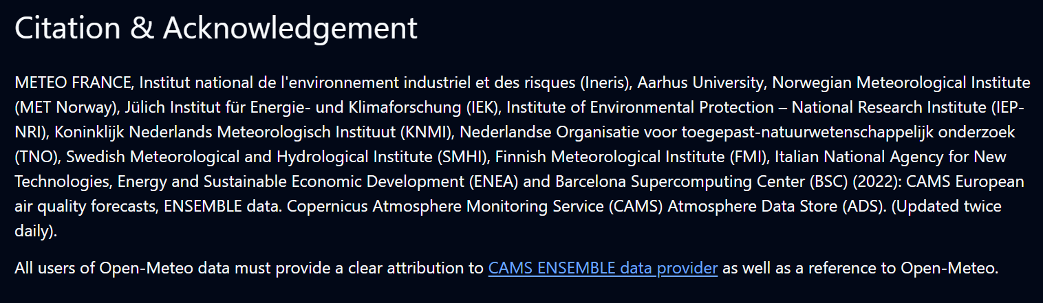
Figure 16: Open-Meteo API Citation and Acknowledgment

